**Survey questions**

Q: Do the results match your understanding of students and the courses?

Q: What were the key insights that you gained from this method?

Q: How would educators find this method and the insights produced valuable?

Q: What further improvements to this method and the insights produced would you such?

Q: How would you use these insights to inform the design of curriculum and content?

**challenge-newbies-2018**

**w1p1**

The algorithm selected and ranked three different slides (slides 5, 4 and 10) in descending order of score. These slides (also known as ranked attributes) are tabulated below, along with their slide number, type and score.

|  |  |  |  |
| --- | --- | --- | --- |
| **Ranked attributes** | **Slide number** | **Slide type** | **Slide score** |
| Slide 5 | Problem | 0.45 |
| Slide 4 | Content | 0.35 |
| Slide 10 | Problem | 0.18 |

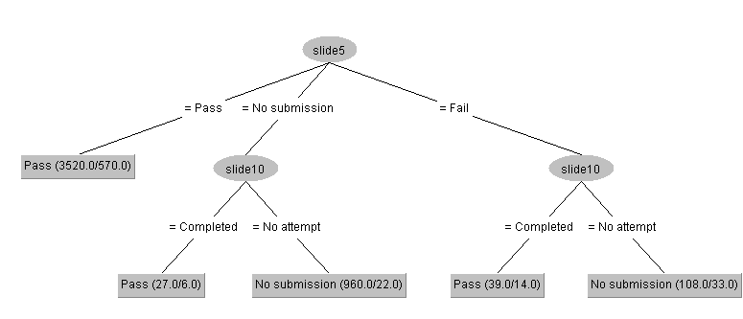

The algorithm also produces a decision tree (shown above). The decision tree contains nodes which are represented by the round shapes with slide numbers, in this case slides 5 and 10, as well as leaves which are represented by the rectangular boxes with the outcome of the last problem in the module, in this case, pass and no submission. The edges represent values that the nodes take.

For instance, starting from the top node (slide 5), if the student passes slide 5, it follows the leftmost edge down to the pass leaf. This means that if a student passes slide 5, according to the algorithm, it will pass the last problem slide (i.e. be classified as a pass).

The numbers at the right end of each leaf represent the number of students that followed the path, followed by the number of students that were misclassified (or went down the wrong path). For instance, Pass (3520.0/ 570.0) means that 3520 students took the left most edge and passed slide 5, and 570.0 were misclassified (i.e. not supposed to be classified as having passed the last problem). 1s

**w1p2**

|  |  |  |  |
| --- | --- | --- | --- |
| **Ranked attributes** | **Slide number** | **Slide type** | **Slide score** |
| Slide 6 | Problem | 0.32 |
| Slide 5 | Problem | 0.27 |
| Slide 10 | Content | 0.06 |

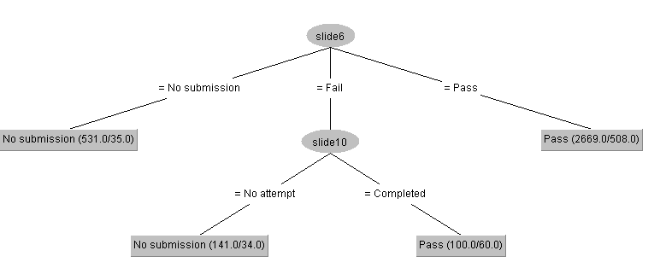

**w2p1**

|  |  |  |  |
| --- | --- | --- | --- |
| **Ranked attributes** | **Slide number** | **Slide type** | **Slide score** |
| Slide 4 | Problem | 0.39 |
| Slide 3 | Problem | 0.31 |
| Slide 6 | Content | 0.09 |

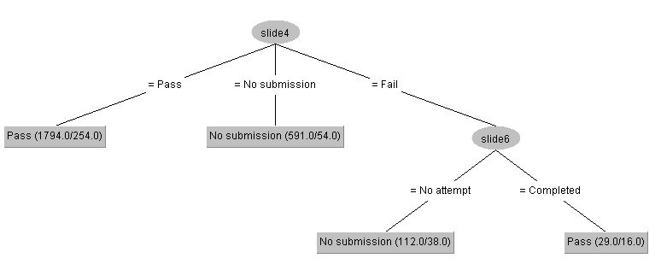

**w2p2**

|  |  |  |  |
| --- | --- | --- | --- |
| **Ranked attributes** | **Slide number** | **Slide type** | **Slide score** |
| Slide 4 | Problem | 0.42 |
| Slide 3 | Problem | 0.38 |
| Slide 8 | Content | 0.07 |

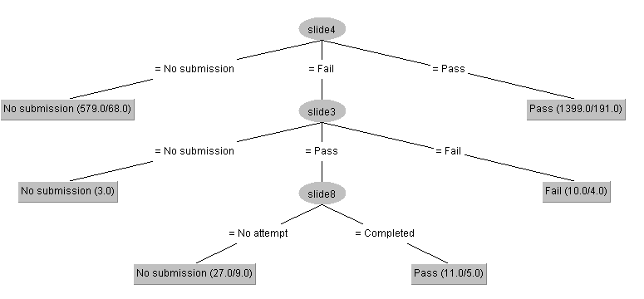

**challenge-beginners-2018**

**w1p2**

|  |  |  |  |
| --- | --- | --- | --- |
| **Ranked attributes** | **Slide number** | **Slide type** | **Slide score** |
| Slide 14 | Problem | 0.65 |
| Slide 7 | Problem | 0.45 |
| Slide 1 |  | 0.31 |

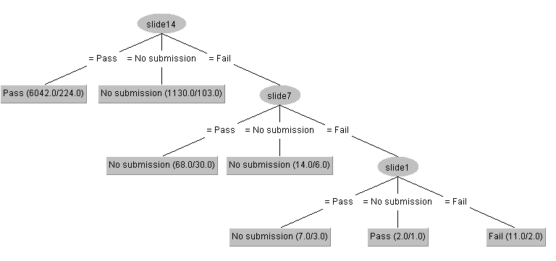

**w2p1**

|  |  |  |  |
| --- | --- | --- | --- |
| **Ranked attributes** | **Slide number** | **Slide type** | **Slide score** |
| Slide 12 | Problem | 0.62 |
| Slide 8 | Problem | 0.50 |
| Slide 4 | Problem | 0.408 |

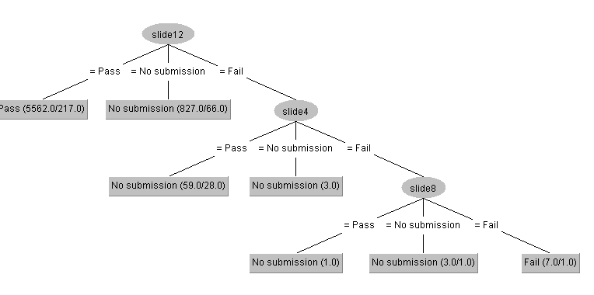

**w2p2**

|  |  |  |  |
| --- | --- | --- | --- |
| **Ranked attributes** | **Slide number** | **Slide type** | **Slide score** |
| 11 | Problem | 0.56 |
| 7 | Problem | 0.43 |
| 4 |  | 0.39 |

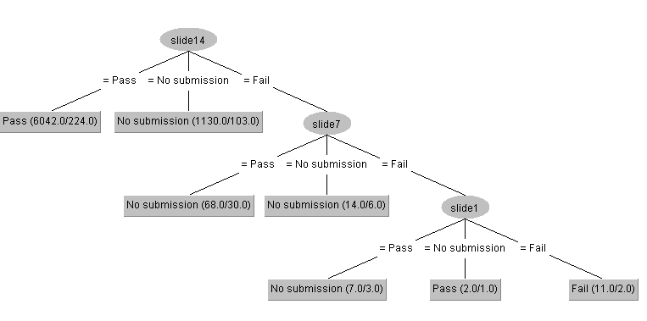

**w4p1**

|  |  |  |  |
| --- | --- | --- | --- |
| **Ranked attributes** | **Slide number** | **Slide type** | **Slide score** |
| 4 | Problem | 0.31 |
| 2 | Problem | 0.21 |
| 8 | Content | 0.11 |

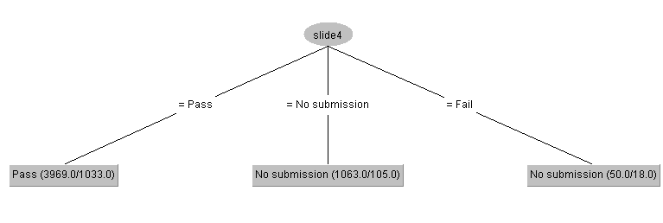

**challenge-intermediate-2018**

**w1p1**

|  |  |  |  |
| --- | --- | --- | --- |
| **Ranked attributes** | **Slide number** | **Slide type** | **Slide score** |
| 8 |  | 0.50 |

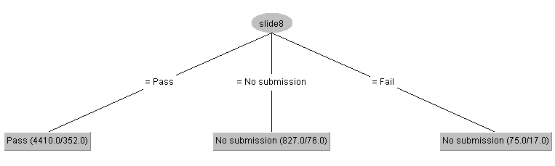

**w1p2**

|  |  |  |  |
| --- | --- | --- | --- |
| **Ranked attributes** | **Slide number** | **Slide type** | **Slide score** |
| 11 | Problem | 0.54 |
| 7 | Problem | 0.42 |
| 13 | Content | 0.03 |

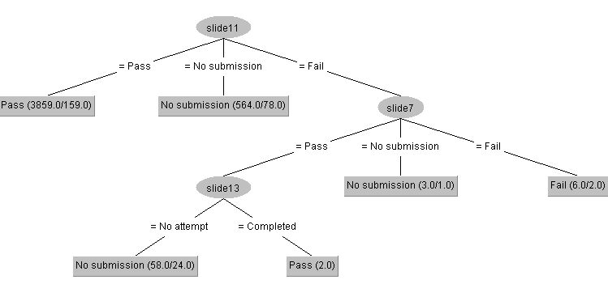

**w3p1**

|  |  |  |  |
| --- | --- | --- | --- |
| **Ranked attributes** | **Slide number** | **Slide type** | **Slide score** |
| 11 | Problem | 0.40 |
| 17 | Content | 0.03 |

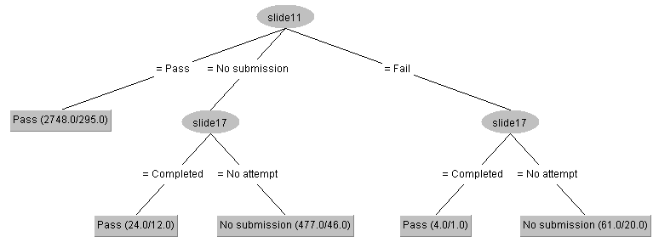

**w3p2**

|  |  |  |  |
| --- | --- | --- | --- |
| **Ranked attributes** | **Slide number** | **Slide type** | **Slide score** |
| 16 | Problem | 0.51 |
| 9 |  | 0.38 |
| 18 |  | 0.03 |

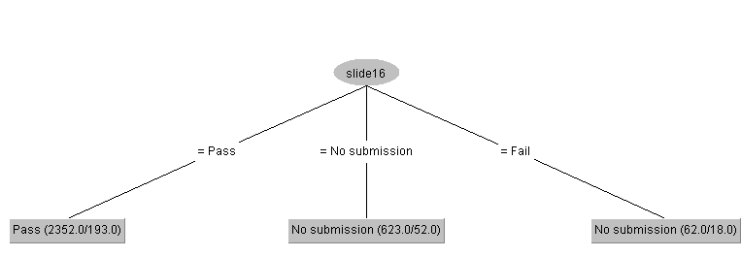

**w4p1**

|  |  |  |  |
| --- | --- | --- | --- |
| **Ranked attributes** | **Slide number** | **Slide type** | **Slide score** |
| 5 | Problem | 0.378 |

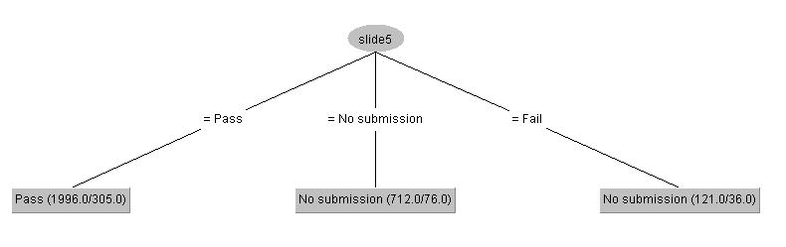

**w5p1**

|  |  |  |  |
| --- | --- | --- | --- |
| **Ranked attributes** | **Slide number** | **Slide type** | **Slide score** |
| 5 | Problem | 0.38 |
| 6 |  | 0.02 |
| 7 |  | 0.02 |

